**Create a Bucket**

* Selecting S3 from the storage of the AWS service panel
* Verifying the button to create a bucket

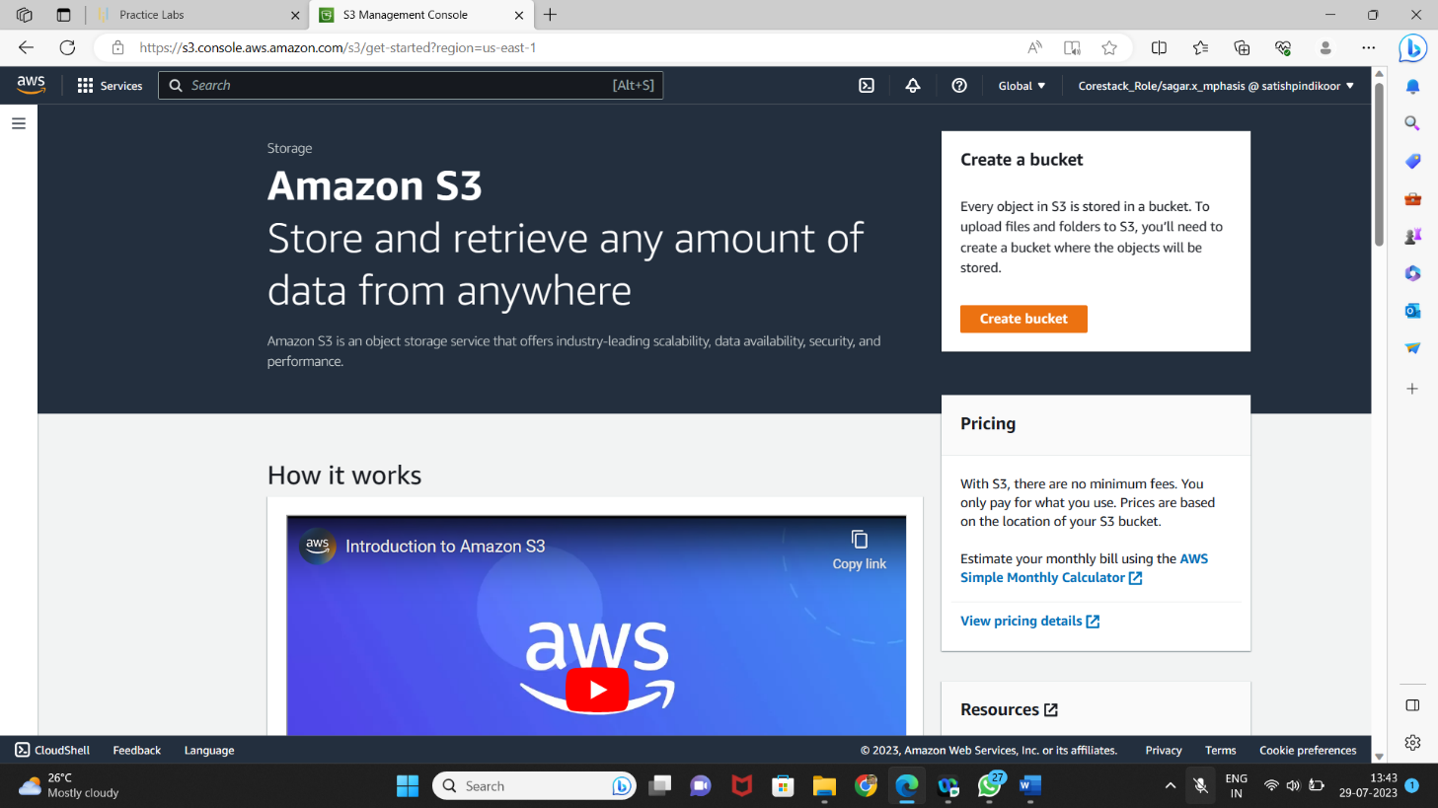

* Providing a bucket name and region
  + Make sure that the bucket name is unique

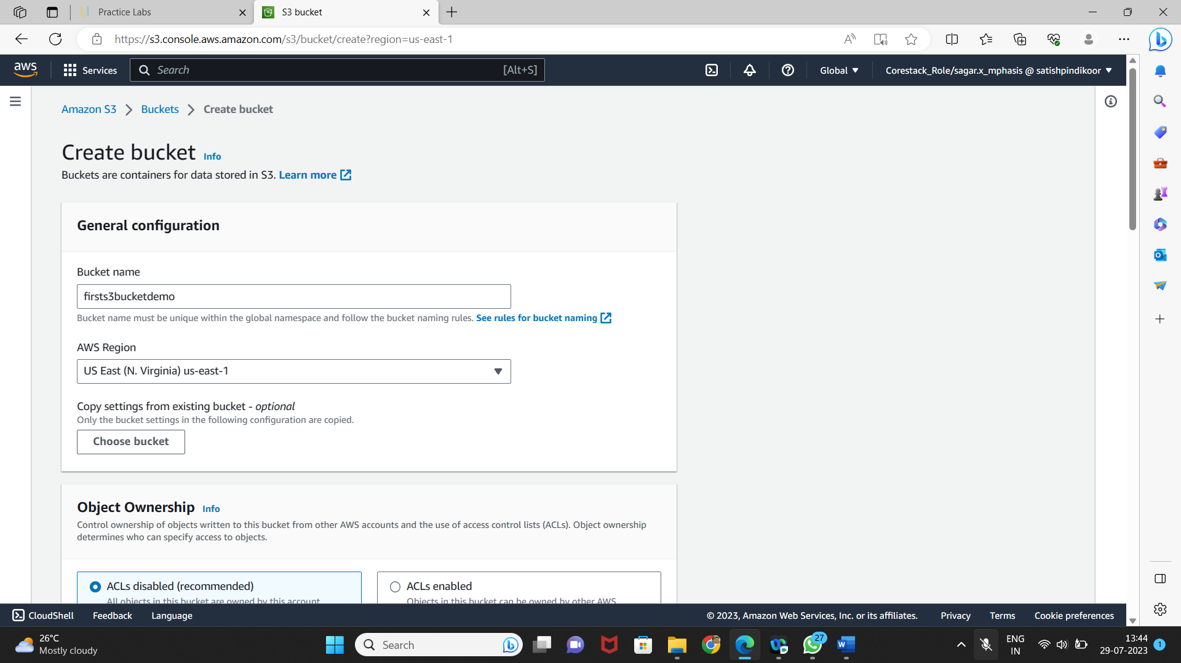

* Entering key and value for identification and tracking the bucket

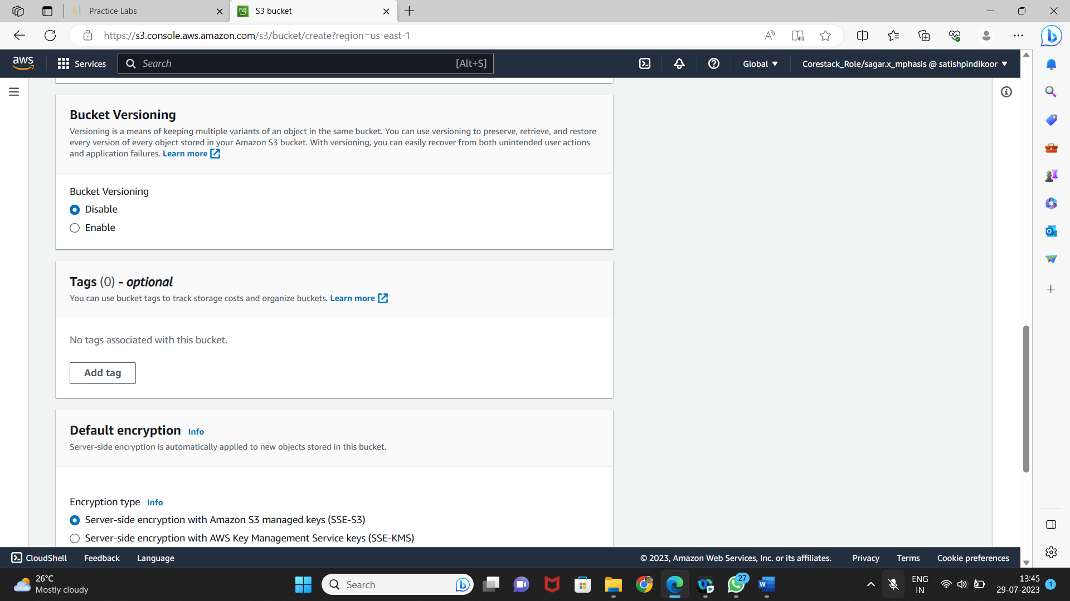

* Blocking all the public access
* If required, you can configure it later

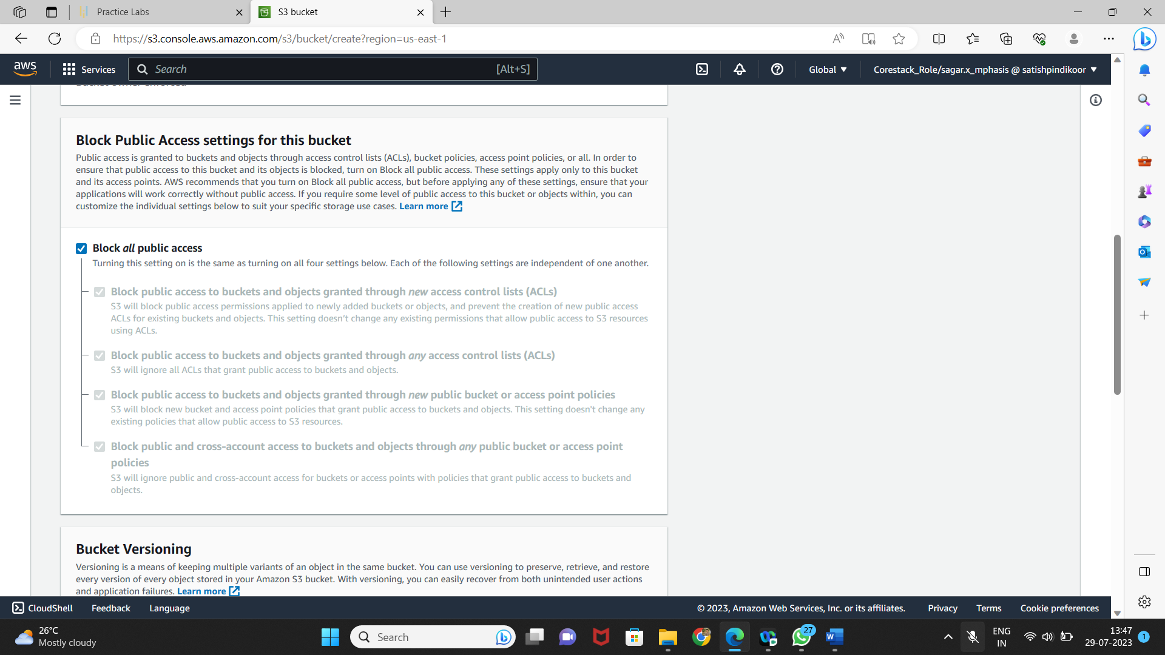

* Reviewing all parameters and creating the bucket

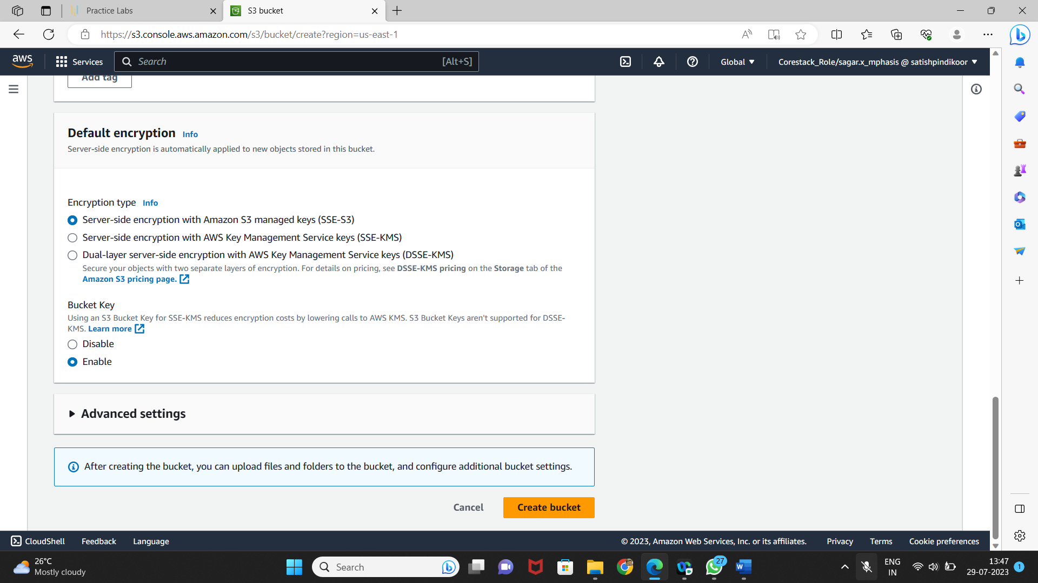

* Verifying the newly created bucket on the panel of S3

